Project Title

**Project Proposal**



**Supervisor**

Supervisor Name

**Submitted by**

1st Student Name

{Enrolment Number }

2nd Student Name

{Enrolment Number }

3rd Student Name

{Enrolment Number }

**Campus Name,**

Riphah International College, Campus Name [Date of Submission]



|  |  |  |  |  |  |  |  |
| --- | --- | --- | --- | --- | --- | --- | --- |
| Project ID  *(for office use)* | | |  | | | | |
| Title of Project | | |  | | | | |
| Type of project | | | [ ] Traditional [ ] Industrial [ ] Continuing | | | | |
| Nature of project | | | [ ] **D**evelopment [ ] **R**esearch [ ] **S**urvey | | | | |
| Area of specialization/ Field | | |  | | | | |
| **Project Group Members** | | | | | | | |
| Sr.# | Reg. # | Student Name | | CGPA | Email ID | Phone # | Signature |
| (i) | Group Leader |  | |  |  |  |  |
| (ii) |  |  | |  |  |  |  |
| (iii) |  |  | |  |  |  |  |
| (iv) |  |  | |  |  |  |  |
| (v) |  |  | |  |  |  |  |
| **Declaration:** FYP group members have cleared all prerequisites courses For FYP-I as per their degree requirements.    **Supervisor Name and Signatures: Principal:**    ___________________________ _________________ | | | | | | | |

|  |
| --- |
| Plagiarism Free Certificate  This is to certify that, I am ________________________ S/D/o _______________________, group leader of FYP under registration no RIC/_______________ at Computer Science Department, Riphah International College Lahore. I declare that my FYP proposal is checked by my supervisor and the similarity index is ________% that is less than 20%, an acceptable limit by HEC. Report is attached herewith as Appendix A.  **Date:** __/__/____ **Name of Group Leader:** ______________________**Signature:** ____________  **Name of Supervisor:** _____________________ **Name of Principal:** ______________________  **Signature:** _____________________ **Signature:** ______________________ |

**Project Registration**



**ABSTRACT**

An Abstract is a summary of the whole technical report. it’s also the last thing you will write but comes first in the document.The Abstract tells the reader the main points about your technical project. Readers may not have a technical background. The Abstract gives them an overview and can help them decide which specific sections to focus on. An academic abstract typically outlines four elements relevant to the completed work: The development/research focus (i.e. statement of the problem(s)/research issue(s) addressed), the methodology used, the results/findings of the work done and the main conclusions and recommendations. Write at least 200 words as abstract of your report.



Table of Contents

Template Guide ............................................................................................................ 12

Project Proposal ..................................................................................................... 1

List of Figures ................................................................................................................ 5



List of Tables ................................................................................................................. 6

1. Introduction ......................................................................................................... 7
2. Objective ............................................................................................................. 7
3. Problem Description ........................................................................................... 7
4. Methodology ....................................................................................................... 7
5. Project Scope ...................................................................................................... 7
6. Feasibility Study ................................................................................................. 7
7. Solution Application Areas ................................................................................. 8
8. Requirements: ..................................................................................................... 8
   1. Hardware Requirements .................................................................................. 8
   2. Software Requirements ................................................................................... 8
   3. Stakeholders: ................................................................................................... 8
9. Tools/Technology ............................................................................................... 9
10. Expertise of the Team Members ..................................................................... 9
11. Timeframe ....................................................................................................... 9
12. Risks & Issues ................................................................................................. 9
13. Milestones ..................................................................................................... 10
14. References ..................................................................................................... 10

List of Figures

Here list of figures will be listed down.

No table of figures entries found.

### List of Tables

Here list of figures will be listed down.

**1. Introduction**

Briefly introduce your project idea.

#### **2. Objective**

Write down your project objective in a very precise and concise manner. Ideally your statement should not exceed 2-3 lines. For example, "*To design a real-time fault-tolerant embedded system for automated gas stations with distributed system architecture*".

#### **3. Problem Description**

A proposal document should address three primary questions in relation to the project objective: *What, Why,* and *How*. This section should describe W*hat* and *Why* of your project. Describe the above mentioned problem in a bit detail. For example, considering the same project, describe what are the benefits and features of automated gas stations, what problems arise when we move from manual to automated systems, what issues should be kept in mind while designing such systems and why such systems should be fault tolerant. Be specific. You are not expected to write more than 250 words.

#### **4. Methodology**

This section would address the ‘*How*’ part. Briefly write down your intended approach towards tackling above problems. Name any algorithm or third party library you would use, any particular technique you are going to follow etc.

#### **5. Project Scope**

An FYP should be defined in terms of its scope. Things you are going to do are almost defined in earlier sections. Here you would outline your project’s scope by declaring what design/development/research aspects you are not going to consider in due course. State any assumption that might dictate your system evolution. For example, in automated gas station project, we are assuming a distributed environment. Remember, never fall into technicalities. What communication media we would be using is irrelevant while defining the project scope.

#### **6. Feasibility Study**

With above defined scope, would you be able to meet your project schedule? Do mention following aspects:

i. **Risks Involved**: Identify the risks involved, and how you would be able to cater? ii. **Resource Requirement**: What computing or any other resource you would need?

#### **7. Solution Application Areas**

Is your project of some real value? Which industry or application domain you are targeting? How that target domain may benefit from your solution?

**8. Requirements:**

Specify basic Hardware and Software requirements of your project. Detailed Requirement specification will be performed later on in SRS.

##### 8.1. Hardware Requirements

(List minimum hardware requirement to run your project on user’s side. Below is the hardware requirement example for a website)

* Processor:
* Hard Disk:
* RAM:
* INPUT and OUTPUT:
* Any Other specific hardware requirement for your project.

##### 8.2. Software Requirements

(List minimum software requirement to run your project on user’s side. Below is the software requirement example for a website)

* Operating System:
* Browser:
* Any other software/Tool requirement.

**8.3. Stakeholders:**

Stakeholders are different people who would be interested in the software or Stakeholders are all those with an interest or role in the project or who are impacted by the project.

We need to understand that it is the actual user who will eventually use the system and hence accept or reject the product. Therefore, ignoring the needs of any user class may result in the system failure. Below picture depicts involvement level of different categories of stakeholders. Identify your project’s stakeholders carefully.

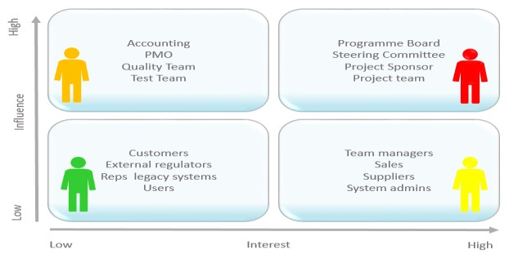

*Figure 1.1 Stakeholders*

**9. Tools/Technology**

Mention all the HW/SW tools/technologies required for the project.

#### **10. Expertise of the Team Members**

Are all team members pre-equipped with the level of knowledge needed for the successful completion of this project? Have you people studied the relevant course by now? Is this project of equal interest to all team members?

#### **11. Timeframe**

This timeframe is critical to success, because if the project delivers the solution after the timeframe specified, then the business may not benefit to the level that was intended.

So you need to specify the timeframe for delivering the project. Describe what the timeframe is and why it is so important that the project deliver the solution within this period of time.

[Specify the timeframe here]

Ideally you will also include an initial project plan for the delivery of the project. Although it is very early stages, the reason for this is that it gives your Project Sponsor confidence that everything has been thought through and that the project can realistically be delivered within the timeframes specified.

Here is an example of a generic project plan:

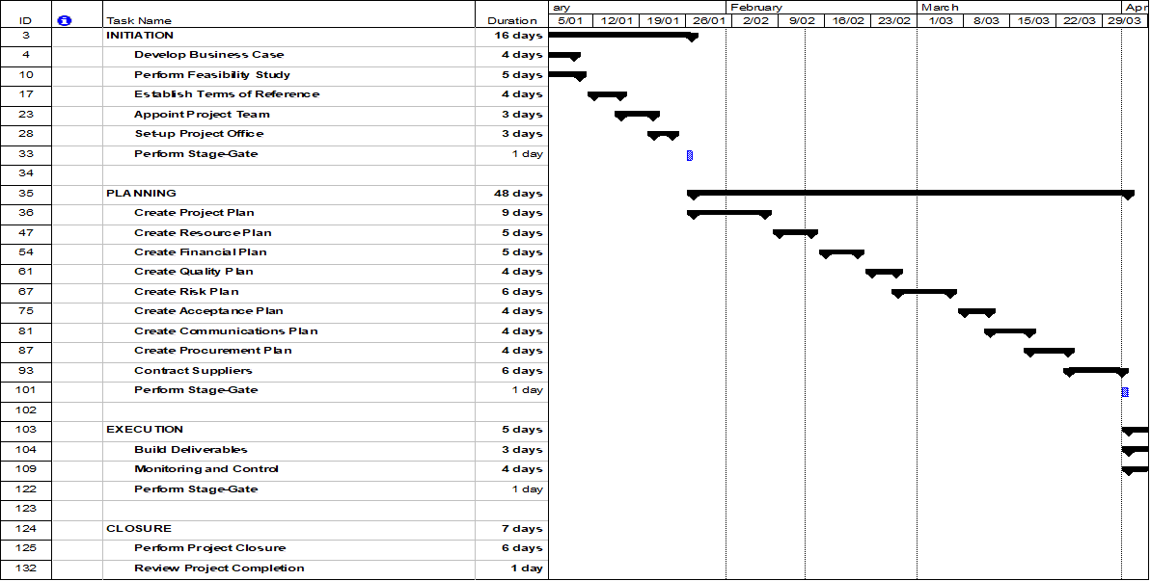

[Include your [Project Plan](https://www.projectmanager.com/templates/project-plan-template) here]

#### **12. Risks & Issues**

Risk and issues occur which try and prevent the project from producing the deliverables on time. Use the following two tables to list all of the known risks and issues upfront.

* Risks: A risk as defined as “any event which could take place in the future that will prevent the project from producing the deliverables on time”. For instance, a risk might be that the business is unable to resource the project fully as required. For each risk, you need to specify the likelihood of it occurring (high/medium/low).
* Issues: An issue is “something that is right now affecting the project”. For instance, it might be that an issue is that at the moment, there is little funding available to initiate a new project such as this one. For each issue, you need specify the impact it is having on your ability to kick off the project.

|  |  |  |  |
| --- | --- | --- | --- |
|  |  | **Project Risks** |  |
|  | **Risk** | **Details** | **Likelihood** |
| [list here] |  | [list here] | [list here] |
| [list here] |  | [list here] | [list here] |
| [list here] |  | [list here] | [list here] |

|  |  |  |  |  |
| --- | --- | --- | --- | --- |
|  |  | **Project Issues** |  |  |
|  | **Issue** | **Details** |  | **Impact** |
| [list here] |  | [list here] | [list here] |  |
| [list here] |  | [list here] | [list here] |  |
| [list here] |  | [list here] | [list here] |  |

#### **13. Milestones**

Mention all major tasks/sub-tasks to be accomplished. You would use these milestones while defining the project timeline.

#### **14. References**

Mention all the literature or web references here. The references should be properly numbered and correctly used in the text.

Reference text should be written in quotes and indented and the references marked in [square brackets]. “Reference material”[1].

The Reference section should be in the following fashion:

* Book: Last Name, First Name. “Tide of Book”. City: Publisher, Copyright Date. Page numbers
* Magazine/ Newspaper Article: Author's last name, Author's first name. "Title of article," Name of magazine/newspaper, date of magazine/newspaper, page number(s).
* Internet Web page: Author. “Title of Web page”. Date on the page. Company associated (if any). Date you last saw the page. URL.
* Online Magazine or Newspaper Articles: Author's last name, Author's first name. "Title of article." Name of magazine, date of magazine, page numbers. Reproduced in Name of Database. Library where database was accessed, location of library. Date of access.

### Template Guideline

**[Note: this section is a guideline and should be removed in your documentation]**

***What is a Project Proposal?***

*A Project Proposal is a document that is written to kick-off a new project. It needs to convince a sponsor that a project needs to be initiated to solve a particular problem or opportunity in the business.*

*It describes in depth, the basis upon which the project needs to be commenced, so that the sponsor fully understands why it’s critical to the business and what is involved.*

*It also needs to outline the implications of* ***not*** *approving the project, so that the sponsor is forced to make a clear decision – to approve the project, or not.*

***When do I use a Project Proposal?***

*Any time that you need to coordinate resources, tasks, equipment and raw materials within a specific timeframe to achieve a particular business goal, then you should consider doing this as part of a formal project.*

*The first step when initiating a project is to document a Project Proposal. It helps you formalize the project so that it has a specific vision that needs to be achieved in order to determine its success.*

*Ideally a Project Proposal will be written by the intended manager of the project. However sometimes it is written by a business manager if the Project Manager is yet to be selected. It is always presented to senior management within the business for approval.*

*Once approved, the next step is usually to write a* [Business Case](https://www.projectmanager.com/blog/how-to-write-a-business-case)*which justifies the project financially. Soon after that,* [*a* Project Charter *w*](https://www.projectmanager.com/templates/project-charter-template)*ill be written based on this Project Proposal, to scope out the project and ensure that everyone is clear about what needs to be done.*

***How to use this template***

*This document outlines the sections needed to complete a Project Proposal. You need to replace the content in each section with your own. Each section includes completion instructions so that you know what you need to write, to fill the document in from start to finish. You will want to remove these completion instructions as you go, to create your own customized Project Charter for your business.*

***Formatting Guidelines***

*A separate formatting guideline is being provided to be followed to make the document formatting as per standards. All research and project-based documentations are strictly followed by formatting standards.*

APA Style Guidelines for Project Documentation Formatting

Table of Contents

Order of Sections 14

Margins & Page Numbers 14

Text Format 14

Tables and Figures In-Text 14

Title Page 14

Body 14

Headings 15

Quotations 15

References 15

Appendices with Tables, Figures, & Illustrations 15

Annotated Bibliography 16

Optional: 16

Abstract 16

Running Head 16

# Order of Sections

1. Title page including Title, Author, University and Department, Class, Instructor, and Date
2. Body (including introduction, literature review or background, discussion, and conclusion)
3. References
4. Appendices (including tables & figures)

# Margins & Page Numbers

* 1 inch at top, bottom, and both sides
* Left aligned paragraphs and leave the right edge ragged (not "right justified")
* Indent first line of each paragraph 1/2 inch from left margin
* Use page numbers, including on the title page, 1/2 inch from top and flush with right margin

# Text Format

* Use one of these highly readable fonts:
  + Times New Roman, 12 point
  + Calibri, 11 point o Arial, 11 point
  + Lucinda Sans Unicode, 10 point o Georgia, 11 point
* Double-space and align text to the left
* Use active voice
* Don't overuse technical jargon
* No periods after a web address or DOI in the References list.

# Tables and Figures In-Text

* Label tables and figures numerically (ex. Table 1)
* Give each table column a heading and use separating lines only when necessary
* Design the table and figure so that it can be understood on its own, i.e. it does not require reference to the surrounding text to understand it
* Notes go below tables and figures

# Title Page

* Include the title, your name, the class name, and the college's name
* Title should be 12 words or less and summarize the paper's main idea
* No periods or abbreviations
* Do not italicize or underline
* No quotation marks, all capital letters, or bold
* Center horizontally in upper half of the page

# Body

* Align the text to the left with a 1/2-inch left indent on the first line
* Double-space
* As long as there is no Abstract, at the top of the first page, type the title of the paper, centered, in **bold**, and in Sentence Case Capitalization
* Usually, include sections like these: introduction, literature review or background, discussion, and conclusion -- but the specific organization will depend on the paper type
* Spell out long organization names and add the abbreviation in parenthesis, then just use the abbreviation
* Spell out numbers one through nine and use a number for 10 or more
* Use a number for units of measurement, in tables, to represent statistical or math functions, and dates or times

# Headings

* Level 1: Center, **bold**, Title Case
* Level 2: Align left, **bold**, Title Case
* Level 3: Alight left, ***bold italics***, Title Case
* Level 4: Indented 1/2", **bold**, Title Case, end with a period. Follow with text.
* Level 5: Indented 1/2", ***bold italics***, Title Case, end with a period. Follow with text.

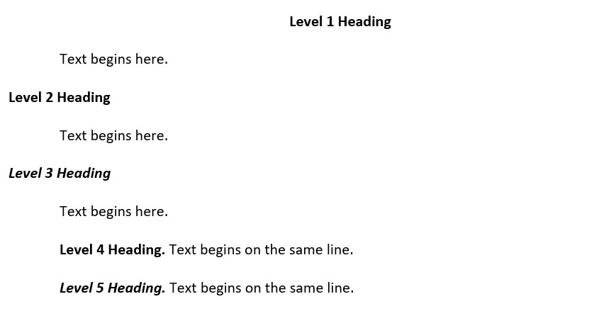

# Quotations

* Include short quotations (40 words or less) in-text with quotation marks
* For quotes more than 40 words, indent the entire quote a half inch from the left margin and double-space it with no quotation marks
* When quoting two or more paragraphs from an original source, indent the first line of each paragraph a half inch from the left margin
* Use ellipsis (...) when omitting sections from a quote and use four periods (....) if omitting the end section of a quote

# References

Begins on a new page following the text of your paper and includes complete citations for the resources you've used in your writing.

* **References** should be centered and bolded at the top of a new page
* Double-space and use hanging indents (where the first line is on the left margin and the following lines are indented a half inch from the left)
* List authors' last name first followed by the first and middle initials (ex. Skinner, B. F.)
* Alphabetize the list by the first author's last name of of each citation (see sections 9.44-9.49)
* Capitalize only the first word, the first after a colon or em dash, and proper nouns
* Don't capitalize the second word of a hyphenated compound
* No quotation marks around titles of articles

# Appendices with Tables, Figures, & Illustrations

* Include appendices only to help the reader understand, evaluate, or replicate the study or argument
* Put each appendix on a separate page and align left
* For text, do not indent the first paragraph, but do indent the rest
* If you have only one appendix, label it "Appendix"
* If you have two or more appendices, label them "Appendix A", "Appendix B" and so forth as they appear in the body of your paper
* Label tables and figures numerically (ex. Table 1, or Table B1 and Table B2 if Appendix B has two tables) and describe them within the text of the appendix
* Give each table column a heading and use separating lines only when necessary
* Notes go below tables and figures (see samples on p. 210-226)

# Annotated Bibliography

* Double-space the entire bibliography. Give each entry a hanging indent. In the following annotation, indent the entire paragraph a half inch from the left margin and give the first line of each paragraph a half inch indent. See the template document at the top of this page.
* Check with your professor for the length of the annotation and which elements you should evaluate.

# Optional:

**These elements are optional, if your professor or field requires them, but they are not required for student papers:**

## Abstract

* Abstract gets its own page
* Center "Abstract" heading and do not indent the first line of the text
* Summarize the main points and purpose of the paper in 150-250 words maximum • Define abbreviations and acronyms used in the paper

## Running Head

* Shorten title to 50 characters or less (counting spaces and punctuation) for the running head
* In the top margin, the running head is aligned left, with the page number aligned on the right
* On every page, put (without the brackets): [SHORTENED TITLE OF YOUR PAPER IN ALL CAPS] [page number]